DS 620 Machine Learning and Deep Learning
HOS10Aa: RNN in TensorFlow
05/26/2022 Developed by Chunhui Xu
05/28/2024 Reviewed by Naveena Moddu
08/21/2025 Reviewed by Ashwin Paturi
11/04/2025 Reviewed by Kina Anh Bui

School of Technology & Computing (STC) @ City University of Seattle (CityU)

Before You Start
- The directory path shown in screenshots may be different from yours.
- The document uses Google Colaboratory as the default compiler. You need to configure the environment if you want to run the code on a local machine.
- Some steps are not explained in the tutorial. If you are not sure what to do:
  - Consult the resources listed below.
  - If you cannot solve the problem after a few tries, ask a TA for help.

Learning objectives
- RNN and LSTM

Resources
- Géron, A. (2019). Hands-on machine learning with scikit-learn, keras, and tensorflow (2nd ed.). O’Reilly Media.
- Loukas, S. (2020, July 10). Time-Series Forecasting: Predicting Stock Prices Using An LSTM Model. Towards Data Science. https://towardsdatascience.com/lstm-time-series-forecasting-predicting-stock-prices-using-an-lstm-model-6223e9644a2f

Introduction: Last week's study found that CNNs can be considered an extended structure based on fully connected layers in neural networks. We also discussed the transformation relation between a CNN layer and a fully connected layer last week. This week, we will also explore RNNs using the fully connected layer. Then, we will learn the LSTM network based on RNNs.

Recurrent Neural Network: First, let's review the fully connected layer. In straightforward terms, the fully connected layer can represent the relationship between the current input and output. For example, if the current input is a picture of a banana, the corresponding current output is the label 'banana'. If I next enter a picture of an apple, it will output the label 'apple'. For now, the apple is entirely unrelated to the banana. In other words, the current output of the fully connected layer is only related to the current input, not the previous one. However, what if we need a model that associates the current output with the input earlier? For example, we want to predict the weather for the coming day from the weather information for the past month. At this point, we have 30 inputs, and the model should collect information for these 30 days before outputting the desired information. Recurrent neural networks (RNNs) can do this.

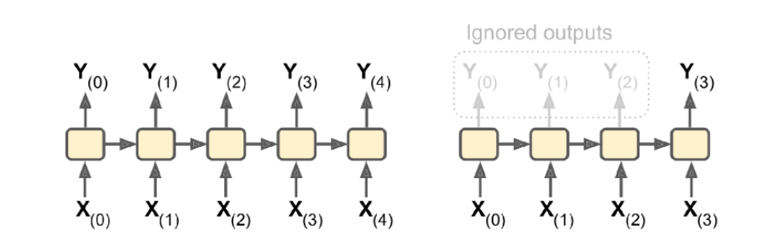
Figure 1: Example RNNs (Géron, 2019)
We can learn more about RNNs based on the diagram in the textbook. The yellow square in the figure can be regarded as a fully connected layer. If there is no information transfer in the lateral direction, then X is the input, and Y is the output. In the presence of horizontal transfer of information, both input and output have temporal information. The output Y(i) is related to all inputs before the current moment. It can also be seen that Y(i) is only related to X(i) and X(i-1); after all, these are directly related. Similarly, since Y(i-1) is also associated with X(i-1) and X(i-2), by analogy, the current moment output is related to all previous inputs. The closer to the current moment, the stronger the relationship. In addition, since the production of each moment has information about the prior moment, there should be another yellow square passing information to the left of the yellow square at moment 0. Therefore, we need to initialize the information using a yellow square. One of the more common methods is to initialize the yellow square into a 0 matrix. The yellow square is updated repeatedly as the input data is entered sequentially. The yellow square will be initialized to that 0 matrix whenever we re-enter the input data set. The parameters we need to train in this model are on the arrows, which pass the information. This part is like a fully connected layer, consisting only of weights and deviations.

Now, let's discuss what RNNs can do. Now that we know RNNs can pass previous input information, it is evident that RNNs can process data with time-series information, such as language. Suppose we have a data set containing “Hello World!”. We can set the training to “Hello World” and the test to “Hello World!”. We can map this dataset to the model on the left side of Figure 1: The X(0) is ‘H’, and the Y(0) is ‘e’; the X(1) is ‘e’, and the Y(1) is ‘l’; and the X(2) is ‘l’, and the Y(2) is ‘l’; and so on. In this way, we can make an alphabet-based natural language processing model. Similarly, the structure on the right-hand side can be used for natural language processing in text classification. We can categorize one-sentence-length text messages into positive, negative, and neutral. Then, we can input words one by one into the RNN network, and eventually, we only use the last output for classification. This structure can also solve the weather prediction problem we initially proposed. We can input the weather information from the previous month in sequence and use the last output as the forecast result for the next day's weather.

Let's create a random number dataset and build an RNN structure ourselves.

Import Libraries
- Go to https://colab.research.google.com. Create a new notebook and name it “RNN_tensorflow.ipynb”.
- Now, we need to import the necessary libraries. Type the following in your code cell, then click the play button or Ctrl + Enter to run the cell.

Data Preparation
- We’ll start by creating a random integer dataset and checking its shape. Click the + Code button to add new code cells. Please type the following code in the cells, then click the play button or Ctrl + Enter to run them.

It is well known that random numbers are not random. This dataset is a staggered stack of a random list of 0 to 9. The feature consists of 4 consecutive random numbers, and the label is the following number. Our next objective is to make the RNN model learn Python's stochastic algorithm using four consecutive random numbers as input and a fifth random number as output.

- Let’s encode the features and labels and divide the data into a training and testing set. Click the + Code button to add new code cells. Type the following code in the cells, then click the play button or Ctrl + Enter to run them.

Encoding and decoding are essential, including in natural language processing. Encoding converts different features into different tensors, while decoding does the opposite. Each encoding method has a corresponding decoding method. One-hot encoding is the simplest and most basic encoding method. For example, one-hot encoding can encode the alphabet, spaces, and symbols. Here, we encode 10 integers from 0 to 9 as one-hot. This has been covered in the previous week, so please refer to HOS09 for more information.

- Next, create a function that reads a batched data set. Click the + Code button to add a new code cell. Type the following code in the cell, then click the play button or Ctrl + Enter to run the cell.

- Now, let’s test the function. Click the + Code button to add a new code cell. Type the following code in the cell, then click the play button or Ctrl + Enter to run the cell.

- Now, it’s time to focus on this exercise: creating the RNN. First, we will create the parameters in the RNN using a function. Click the + Code button to add new code cells. Type the following code in the cells, then click the play button or Ctrl + Enter to run them.

The normal function is used to create weights in the RNN, and the get_params function is used to create all the parameters in the RNN. We can think of the previous yellow square as the hidden layer H with the input X. W_xh represents the weights in the arrow that points to the yellow square H from the input X, W_hh represents the weights in the horizontal arrow, and b_h is the bias of them. W_hq represents the weights in the arrow pointing to the output from the yellow square, and b_q is its bias.

- Next, we’ll define the function initializing the yellow square. Click the + Code button to add a new code cell. Type the following code in the cell, then click the play button or Ctrl + Enter to run the cell.

- We must also define the function used to execute the RNN process. Click the + Code button to add a new code cell. Type the following code in the cell, then click the play button or Ctrl + Enter to run the cell.

- Let’s define another function to calculate the accuracy. Click the + Code button to add a new code cell. Type the following code in the cell, then click the play button or Ctrl + Enter to run the cell.

- Now, integrate the previous functions and create an RNN model. Click the + Code button to add new code cells. Type the following code in the cells, then click the play button or Ctrl + Enter to run them.

- We also need to set the loss function and optimizer. Click the + Code button to add a new code cell. Type the following code in the cell, then click the play button or Ctrl + Enter to run the cell.

- Next, we’ll define a function to train the model. Click the + Code button to add a new code cell. Type the following code in the cell, then click the play button or Ctrl + Enter to run the cell.

- Finally, let’s train 100 epochs. Click the + Code button to add new code cells. Type the following code in the cells, then click the play button or Ctrl + Enter to run them.

Note: This is only a snippet of the beginning of the output
.
As you may notice, the loss is decreasing, and the accuracy is increasing over each epoch. At the end of training, the model has around 12.4% accuracy. If the number is chosen randomly, the expectation of correctness is 10%, which means the RNN model performs poorly.

- Let’s check the testing set. Click the + Code button to add a new code cell. Type the following code in the cell, then click the play button or Ctrl + Enter to run the cell.

Here, we can see that the accuracy of the testing set is about 10%. In other words, our model doesn’t work in this case. This means that our model overfits the training set. To put it bluntly, our model memorized the training set but did not learn the underlying random number algorithm. If you are interested, you can try to change the length of the training set to 100,000 or 1,000,000 and the input to 100 or 1,000 data simultaneously to predict the next one. (In this project, the training set shape is only 7000, 4, 10).

We have finished creating our RNN model for now. However, you may still have many questions.

In our code, we set the batch size to 200. Batch size is a crucial hyperparameter used to control the input data size when we train a model. We also put the batch size in the last HOS (Hands-on Skills). It is used to parallelize the operation, which involves training multiple datasets simultaneously. For a data set of 1000, inputting one by one takes 1000 times, whereas setting the batch size to 200 reduces this to 5 inputs. This approach works well in image classification, but it raises a question: for image classification, we can input data in large batches, but for data with time series information, how do we parallelize it? For example, an image classification input data size is (200, 32, 32, 3). The batch size is 200, and the image size is 32x32x3, so we can input 200 images together. However, the time series information size is (200, 4, 10), the same as our project. The batch size is 200, the time series is 4, and the information size is 10. The input size of the RNN model is (10). We should input the information four times in a specific sequence to maintain the time series. At the same time, we also want to input 200 data together. How can we do that?

The solution is matrix transpose. Let’s transpose the data size (200, 4, 10) to (4, 200, 10). Then, we can follow the time series and input (200, 10) size data four times. This is why we use tf.transpose() in step 15.
Above, we explored creating an RNN model manually, but now, let's try using one directly from the TensorFlow library.

- Click the + Code button to add new code cells. Please type the following code in the cells, then click the play button or Ctrl + Enter to run them.

The metric we are using here is the accuracy function we created before.

- Now, let’s train and evaluate the model. Click the + Code button to add a new code cell. Type the following code in the cell, then click the play button or Ctrl + Enter to run the cell.

Note: This is only a snippet of the beginning of the output.

This result is similar to that of the RNN model we created.

Long Short-Term Memory: As we mentioned, RNNs are models strongly correlated with the current and the previous moment. If a critical message appears a long time ago and never appears again, then this message is likely to be forgotten by the RNN model. For example, “Apple is my favorite fruit, so I want to buy some ____.” In this case, the blank is most likely “apple” because the “apple” appears at the beginning. However, this information seems too early. The RNN model is strongly correlated with the current and previous moments, so it may be aware of the “buy some” thing, but doesn’t know what to buy. We need to find a way to help the model retain information from a long time ago.

As its name suggests, long Short-Term Memory (LSTM) can do this.

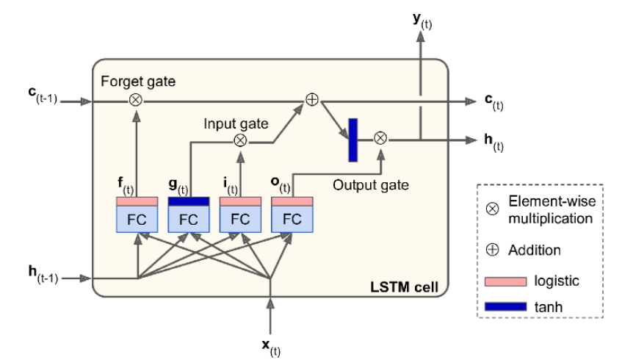
Figure 2: LSTM Cell (Géron, 2019)

Figure 2 shows the LSTM structure as included in the textbook. c is used to store long-term memories, and h is used to store short-term memories. Let’s analyze this image from the left.

First, the input x and the previous h are used to make the previous forget some useless information by the f and forget gate. Next, the input x and the previous h analyze the vital information at the current moment by using g and i, and update c by the input date. After that, the previous c is renewed to the current c. In the end, the previous h and input x are integrated by o, and the output gate obtains long-term information from the current c. The previous h is updated to the current h. The current h obtains the output y through a fully connected layer.

- Let’s use the TensorFlow library to create and compile an LSTM model. Click the + Code button to add new code cells. Please type the following code in the cells, then click the play button or Ctrl + Enter to run them.

- Now, let’s train and evaluate the model. Click the + Code button to add a new code cell. Type the following code in the cell, then click the play button or Ctrl + Enter to run the cell.

Note: This is only a snippet of the beginning and end of the output.

This result is also similar to the previous two networks, with a slight improvement. LSTM works better if the series is long.

Push your work to GitHub
Click File → Download → Download .ipynb.
The file will be downloaded to your Download folder (or another folder according to your browser settings).

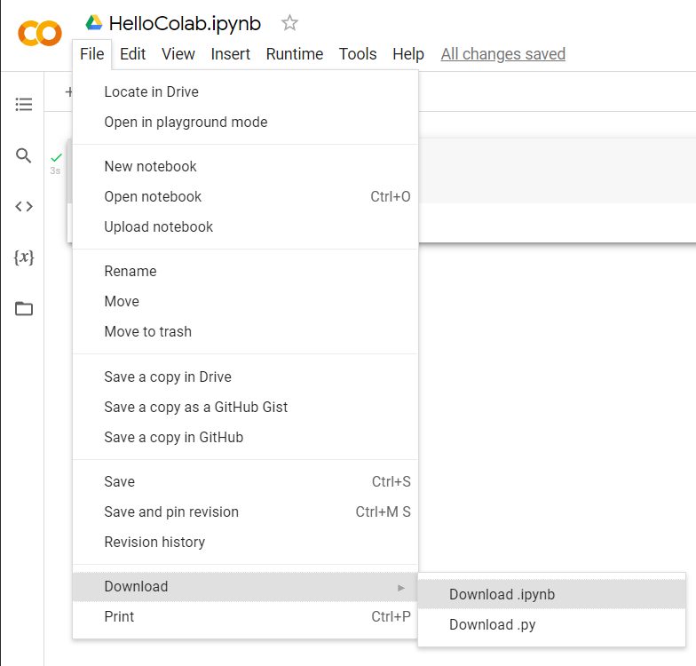

Move the downloaded ipynb file to your Module 10 folder.
Follow the instructions on the CityU STC TA Center Github.io Submit your work page.

